1. **Introduction:**

Zoho Books is your one-step platform for managing your accounting tasks and organizing

your transactions. It’s a single secure location to keep up with your company’s bills and invoices,

reconcile your bank statements, control your spending, oversee projects, and eliminate GST

compliance worries.

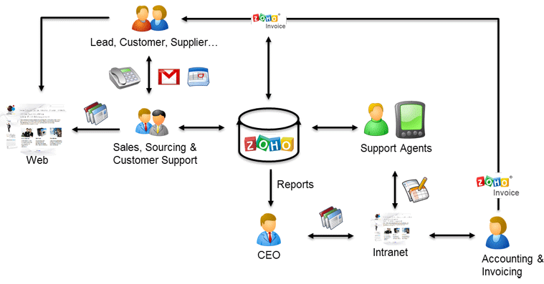

1. **Problem definition & design Thinking**
   1. *Empathy map*

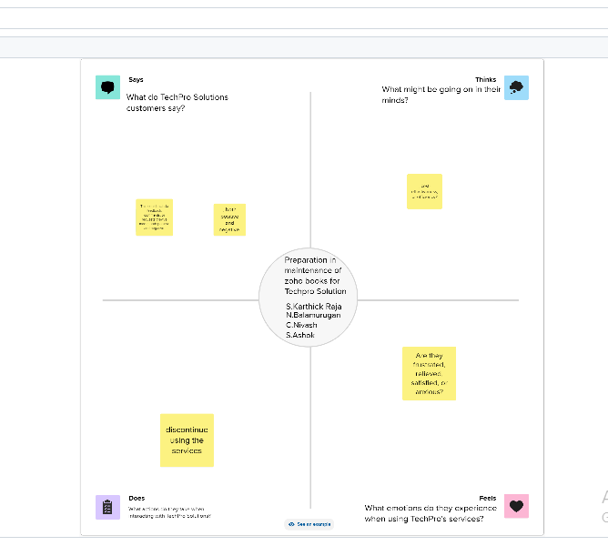

* 1. *Ideation & Brainstorming map*

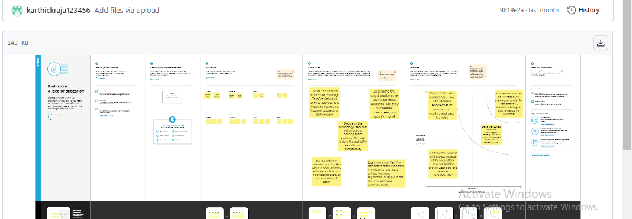

1. **Result Profit&loss**

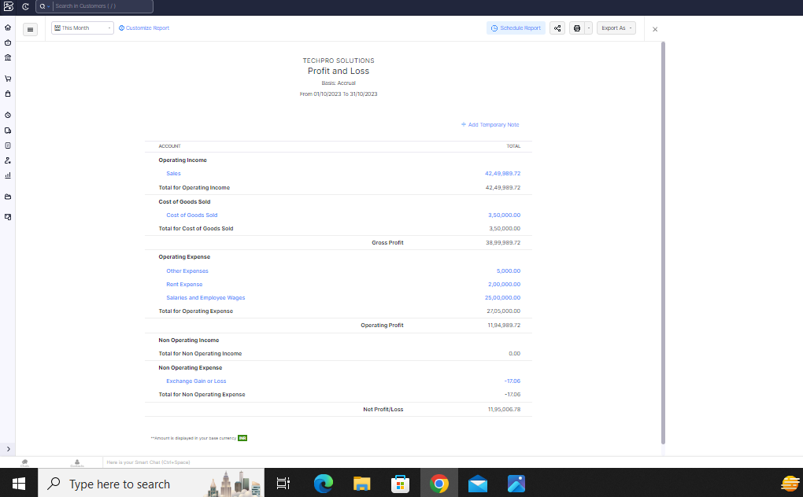

Balance sheet:

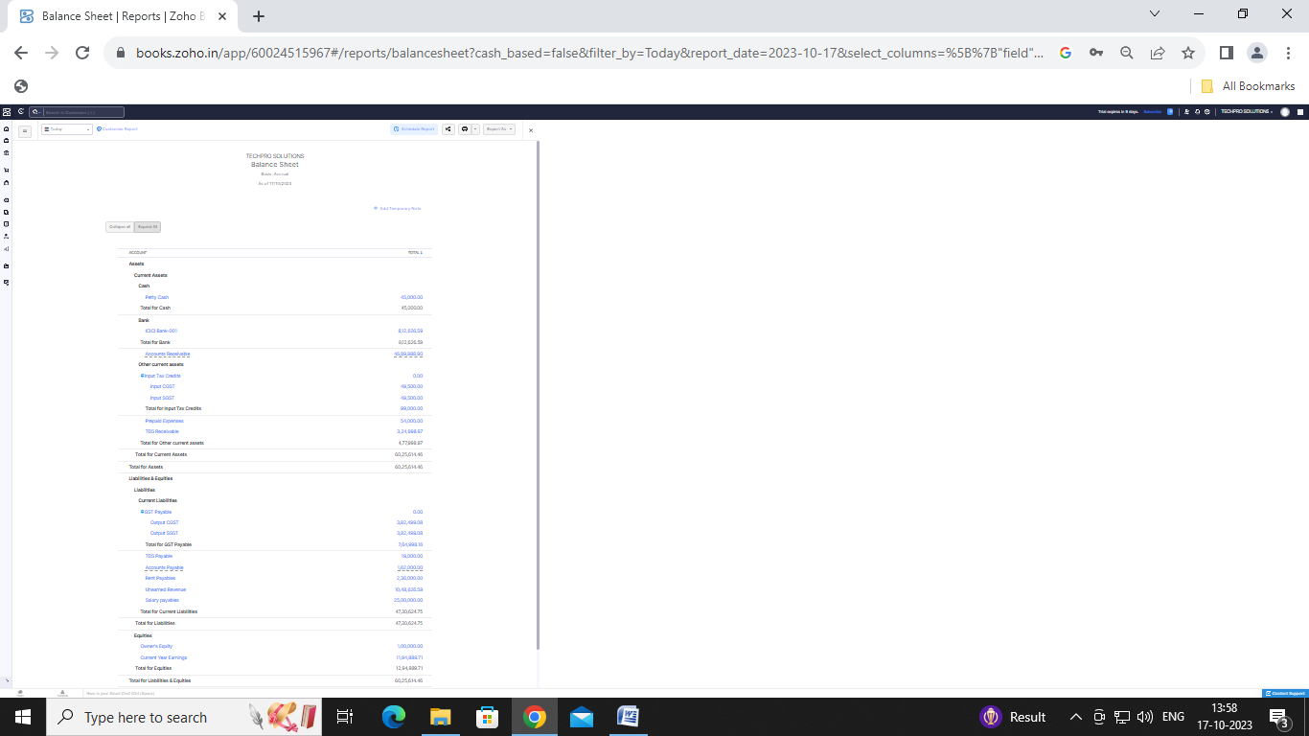

Purchase order:

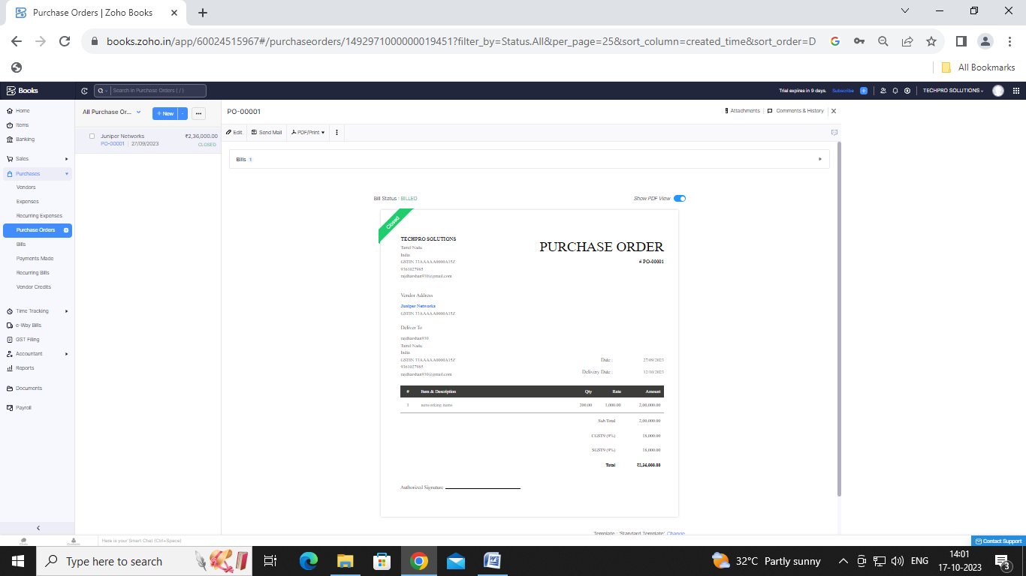

**SALES ORDER:**

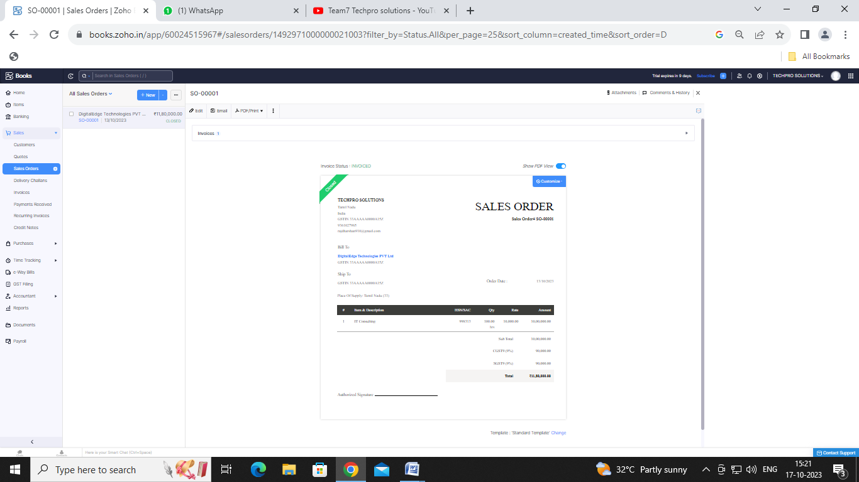

**INVOICE:**

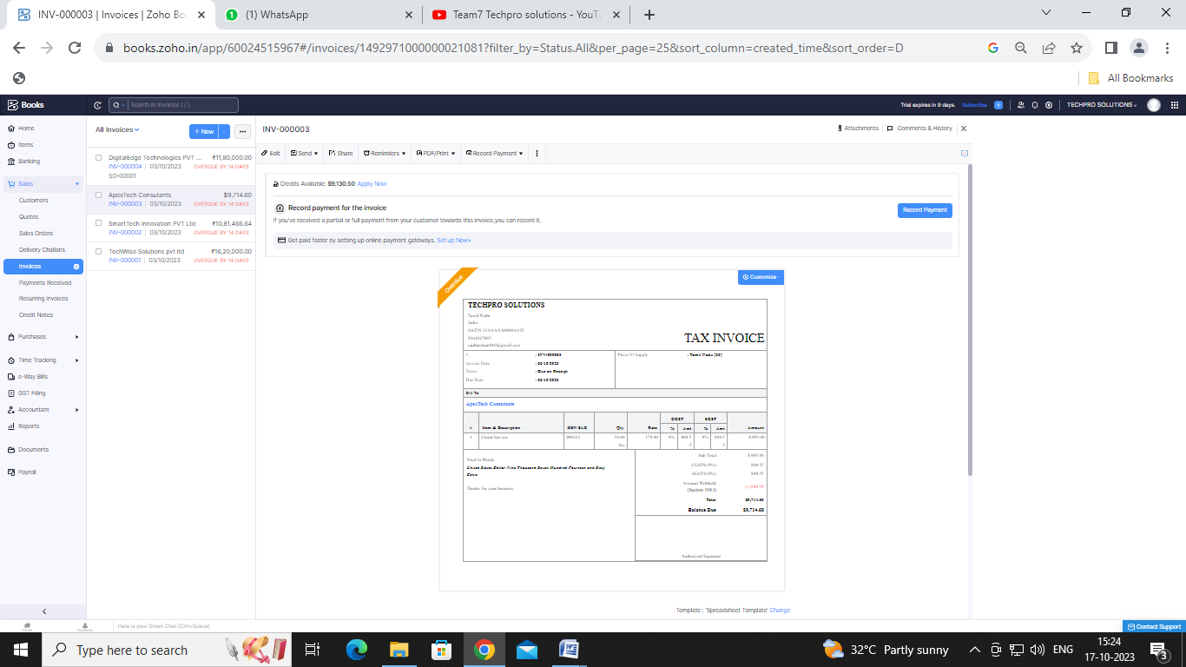

**BILLS:**

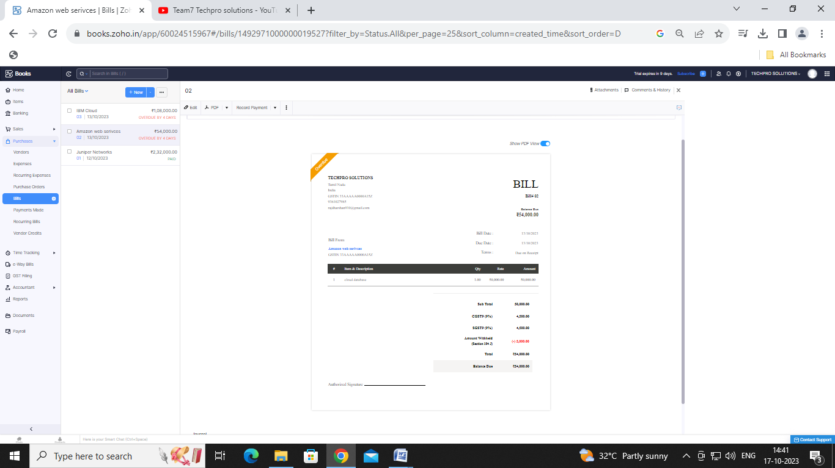

ADVANTAGES OF TECH PRO SOLUTIONS:

We can build you a smart and powerful Ecommerce mobile application that is easy to use, packed with features and functionality, compatible with all devices and optimized for the best performance. Our team of developers will work closely with you to create an app that is tailored to your business needs.

DISADVANTAGES OF TECH PRO SOLUTIONS:

Monthly transaction cap. One significant Zoho Books limitation is the cap on monthly transactions. Multiple subscriptions for multiple businesses. Additional users require a fee. Fewer integrations than competitors. No payroll services. Accounts payable limitations.

1. ***APPLICATIONS****:*

***Contact management. Online payments. Inventory management. Expenses . mobile apps.***

1. **Conclusion:**

**To conclude, Zoho Books is easy to understand and its configuration is quick and easy. The automation of the system is great and you save a lot of time.**

1. **FUTURE SCOPE:**

This edition, available for free to students in India, offers aspiring CAs and future finance professionals a modern accounting solution that helps them put their theoretical learning into practical use, while equipping them with the knowledge required to not only streamline their own firm’s financial operations but also their future clients.

1. **APPENDIX:**

[**https://github.com/karthickraja123456/techpro-solutions_NM2023TMID23107?search=1**](https://github.com/karthickraja123456/techpro-solutions_NM2023TMID23107?search=1)

|  |
| --- |
| <!DOCTYPE html> |
|  | <html lang="en" data-color-mode="auto" data-light-theme="light" data-dark-theme="dark" data-a11y-animated-images="system" data-a11y-link-underlines="false"> |
|  |  |
|  | <style> |
|  | /* for each iteration, uncomment the CSS variable */ |
|  |  |
|  | /* light themes */ |
|  | [data-color-mode="light"][data-light-theme*="light"], |
|  | [data-color-mode="auto"][data-light-theme*="light"] { |
|  | /* iteration 1 */ |
|  | --border-color-iteration-1: #C8CCD0; |
|  | /* iteration 2 */ |
|  | --border-color-iteration-2: #BABFC5; |
|  | /* iteration 3 */ |
|  | --border-color-iteration-3: #A6ADB4; |
|  | /* iteration final */ |
|  | --border-color-iteration-4: #868F99; |
|  |  |
|  | /* the first value is the final step, which falls back to previous iterations */ |
|  | --control-borderColor-rest: var(--border-color-iteration-4, var(--border-color-iteration-3, var(--border-color-iteration-2, var(--border-color-iteration-1)))) !important; |
|  | } |
|  |  |
|  | /* dark themes */ |
|  | [data-color-mode="dark"][data-dark-theme*="dark"], |
|  | [data-color-mode="auto"][data-light-theme*="dark"] { |
|  | /* iteration 1 */ |
|  | --border-color-iteration-1: #363940; |
|  | /* iteration 2 */ |
|  | --border-color-iteration-2: #3F434B; |
|  | /* iteration 3 */ |
|  | --border-color-iteration-3: #4B5159; |
|  | /* iteration final */ |
|  | --border-color-iteration-4: #666E79; |
|  |  |
|  | /* the first value is the final step, which falls back to previous iterations */ |
|  | --control-borderColor-rest: var(--border-color-iteration-4, var(--border-color-iteration-3, var(--border-color-iteration-2, var(--border-color-iteration-1)))) !important; |
|  | } |
|  |  |
|  | [data-color-mode="dark"][data-dark-theme="dark_dimmed"], |
|  | [data-color-mode="dark"][data-dark-theme="light_high_contrast"], |
|  | [data-color-mode="dark"][data-dark-theme="dark_high_contrast"], |
|  | [data-color-mode="light"][data-light-theme="dark_dimmed"], |
|  | [data-color-mode="light"][data-light-theme="light_high_contrast"], |
|  | [data-color-mode="light"][data-light-theme="dark_high_contrast"] { |
|  | /* skip these themes, use the fallback */ |
|  | --control-borderColor-rest: initial !important; |
|  | } |
|  |  |
|  | @media (prefers-color-scheme: dark) { |
|  | /* dark colors in dark mode */ |
|  | [data-color-mode="auto"][data-dark-theme*="dark"] { |
|  | /* iteration 1 */ |
|  | --border-color-iteration-1: #363940; |
|  | /* iteration 2 */ |
|  | --border-color-iteration-2: #3F434B; |
|  | /* iteration 3 */ |
|  | --border-color-iteration-3: #4B5159; |
|  | /* iteration final */ |
|  | --border-color-iteration-4: #666E79; |
|  |  |
|  | /* the first value is the final step, which falls back to previous iterations */ |
|  | --control-borderColor-rest: var(--border-color-iteration-4, var(--border-color-iteration-3, var(--border-color-iteration-2, var(--border-color-iteration-1)))) !important; |
|  | } |
|  |  |
|  | /* light colors in dark mode */ |
|  | [data-color-mode="auto"][data-dark-theme*="light"] { |
|  | /* iteration 1 */ |
|  | --border-color-iteration-1: #C8CCD0; |
|  | /* iteration 2 */ |
|  | --border-color-iteration-2: #BABFC5; |
|  | /* iteration 3 */ |
|  | --border-color-iteration-3: #A6ADB4; |
|  | /* iteration final */ |
|  | --border-color-iteration-4: #868F99; |
|  |  |
|  | /* the first value is the final step, which falls back to previous iterations */ |
|  | --control-borderColor-rest: var(--border-color-iteration-4, var(--border-color-iteration-3, var(--border-color-iteration-2, var(--border-color-iteration-1)))) !important; |
|  | } |
|  |  |
|  | [data-color-mode="auto"][data-dark-theme="dark_dimmed"], |
|  | [data-color-mode="auto"][data-dark-theme="light_high_contrast"], |
|  | [data-color-mode="auto"][data-dark-theme="dark_high_contrast"] { |
|  | /* skip these themes, use the fallback */ |
|  | --control-borderColor-rest: initial !important; |
|  | } |
|  | } |

z-index: 2147483647; transition:

width 300ms ease-out, opacity 150ms 150ms ease-in; transform: translate3d(0, 0, 0);

}

</style>

<link crossorigin=”anonymous” media=”all” rel=”stylesheet” href=”./NM2023TMID22539_profit_and_loss.pdf at main · asmku643mku643c1c31260_NM2023TMID22539 · GitHub_files/light-b92e9647318f.css”><link crossorigin=”anonymous” media=”all” rel=”stylesheet” href=”./NM2023TMID22539_profit_and_loss.pdf at main · asmku643mku643c1c31260_NM2023TMID22539 · GitHub_files/dark-5d486a4ede8e.css”><link data-color-theme=”dark_dimmed” crossorigin=”anonymous” media=”all” rel=”stylesheet” data-href=https://github.githubassets.com/assets/dark_dimmed-27c8d635e4e5.css><link data-color-theme=”dark_high_contrast” crossorigin=”anonymous” media=”all”

rel=”stylesheet”

data-href=https://github.githubassets.com/assets/dark_high_contrast-8438e75afd36.css><lin k data-color-theme=”dark_colorblind” crossorigin=”anonymous” media=”all” rel=”stylesheet” data-href=https://github.githubassets.com/assets/dark_colorblind-bf5665b96628.css><link data-color-theme=”light_colorblind” crossorigin=”anonymous” media=”all” rel=”stylesheet” data-href=https://github.githubassets.com/assets/light_colorblind-c414b5ba1dce.css><link data-color-theme=”light_high_contrast” crossorigin=”anonymous” media=”all” rel=”stylesheet”

data-href=https://github.githubassets.com/assets/light_high_contrast-e5868b7374db.css><lin k data-color-theme=”light_tritanopia” crossorigin=”anonymous” media=”all” rel=”stylesheet” data-href=https://github.githubassets.com/assets/light_tritanopia-299ac9c64ec0.css><link data-color-theme=”dark_tritanopia” crossorigin=”anonymous” media=”all” rel=”stylesheet” data-href=h[ttps://github.githubassets.com/assets/dark_tritanopia-3a26e78ad0ff.css>](https://github.githubassets.com/assets/light_high_contrast-e5868b7374db.css)

<link cros[sorigin=”anonymous” media=”all” rel=”stylesheet”](https://github.githubassets.com/assets/dark_tritanopia-3a26e78ad0ff.css) href=”./NM2023TMID22539_profit_and_loss.pdf at main · asmku643mku643c1c31260_NM2023TMID22539 · GitHub_files/primer-primitives-6143c8f97ed1.css”>

<link crossorigin=”anonymous” media=”all” rel=”stylesheet” href=”./NM2023TMID22539_profit_and_loss.pdf at main · asmku643mku643c1c31260_NM2023TMID22539 · GitHub_files/primer-d6dcdf72e61d.css”>

<link crossorigin=”anonymous” media=”all” rel=”stylesheet” href=”./NM2023TMID22539_profit_and_loss.pdf at main · asmku643mku643c1c31260_NM2023TMID22539 · GitHub_files/global-ab1c3e3e5644.css”>

<link crossorigin=”anonymous” media=”all” rel=”stylesheet” href=”./NM2023TMID22539_profit_and_loss.pdf at main · asmku643mku643c1c31260_NM2023TMID22539 · GitHub_files/github-757ef6ea9a38.css”>

<link crossorigin=”anonymous” media=”all” rel=”stylesheet” href=”./NM2023TMID22539_profit_and_loss.pdf at main · asmku643mku643c1c31260_NM2023TMID22539 · GitHub_files/code-71ecd5638fbf.css”>

<script type=”application/json”

id=”client-env”>{“locale”:”en”,”featureFlags”:[“failbot_handle_non_errors”,”geojson_azure_m aps”,”image_metric_tracking”,”turbo_experiment_risky”,”sample_network_conn_type”]}</scri pt>

<script crossorigin=”anonymous” defer=”defer” type=”application/javascript” src=”./NM2023TMID22539_profit_and_loss.pdf at main · asmku643mku643c1c31260_NM2023TMID22539 ·

GitHub_files/wp-runtime-86f14561f3b0.js.download”></script>

<script crossorigin=”anonymous” defer=”defer” type=”application/javascript” src=”./NM2023TMID22539_profit_and_loss.pdf at main · asmku643mku643c1c31260_NM2023TMID22539 ·

GitHub_files/vendors-node_modules_dompurify_dist_purify_js-64d590970fa6.js.download”>

</script>

<script crossorigin=”anonymous” defer=”defer” type=”application/javascript” src=”./NM2023TMID22539_profit_and_loss.pdf at main · asmku643mku643c1c31260_NM2023TMID22539 ·

GitHub_files/vendors-node_modules_stacktrace-parser_dist_stack-trace-parser_esm_js-node_ modules_github_bro-a4c183-18bf85b8e9f4.js.download”></script>

<script crossorigin=”anonymous” defer=”defer” type=”application/javascript” src=”./NM2023TMID22539_profit_and_loss.pdf at main · asmku643mku643c1c31260_NM2023TMID22539 ·

GitHub_files/ui_packages_soft-nav_soft-nav_ts-56133143b228.js.download”></script>

<script crossorigin=”anonymous” defer=”defer” type=”application/javascript” src=”./NM2023TMID22539_profit_and_loss.pdf at main · asmku643mku643c1c31260_NM2023TMID22539 ·

GitHub_files/environment-fc6543d75794.js.download”></script>

<script crossorigin=”anonymous” defer=”defer” type=”application/javascript” src=”./NM2023TMID22539_profit_and_loss.pdf at main · asmku643mku643c1c31260_NM2023TMID22539 ·

GitHub_files/vendors-node_modules_github_selector-observer_dist_index_esm_js-2646a2c53 3e3.js.download”></script>

<script crossorigin=”anonymous” defer=”defer” type=”application/javascript” src=”./NM2023TMID22539_profit_and_loss.pdf at main · asmku643mku643c1c31260_NM2023TMID22539 ·

GitHub_files/vendors-node_modules_primer_behaviors_dist_esm_focus-zone_js-d55308df50 23.js.download”></script>

<script crossorigin=”anonymous” defer=”defer” type=”application/javascript” src=”./NM2023TMID22539_profit_and_loss.pdf at main · asmku643mku643c1c31260_NM2023TMID22539 ·

GitHub_files/vendors-node_modules_github_relative-time-element_dist_index_js-99e288659 d4f.js.download”></script>

<script crossorigin=”anonymous” defer=”defer” type=”application/javascript” src=”./NM2023TMID22539_profit_and_loss.pdf at main · asmku643mku643c1c31260_NM2023TMID22539 ·

GitHub_files/vendors-node_modules_fzy_js_index_js-node_modules_github_combobox-nav_ dist_index_js-node_modu-344bff-91b70bb50d68.js.download”></script>

<script crossorigin=”anonymous” defer=”defer” type=”application/javascript” src=”./NM2023TMID22539_profit_and_loss.pdf at main · asmku643mku643c1c31260_NM2023TMID22539 ·

GitHub_files/vendors-node_modules_delegated-events_dist_index_js-node_modules_github_ auto-complete-element-81d69b-f766607dc0c8.js.download”></script>

<script crossorigin=”anonymous” defer=”defer” type=”application/javascript” src=”./NM2023TMID22539_profit_and_loss.pdf at main · asmku643mku643c1c31260_NM2023TMID22539 ·

GitHub_files/vendors-node_modules_github_filter-input-element_dist_index_js-node_module s_github_remote-inp-2e8678-d593bf262480.js.download”></script>

<script crossorigin=”anonymous” defer=”defer” type=”application/javascript” src=”./NM2023TMID22539_profit_and_loss.pdf at main · asmku643mku643c1c31260_NM2023TMID22539 ·

GitHub_files/vendors-node_modules_github_file-attachment-element_dist_index_js-node_m odules_primer_view-co-70ad06-9f8bb7e4a8fa.js.download”></script>

<script crossorigin=”anonymous” defer=”defer” type=”application/javascript” src=”./NM2023TMID22539_profit_and_loss.pdf at main · asmku643mku643c1c31260_NM2023TMID22539 ·

GitHub_files/github-elements-30961cfd137b.js.download”></script>

<script crossorigin=”anonymous” defer=”defer” type=”application/javascript” src=”./NM2023TMID22539_profit_and_loss.pdf at main · asmku643mku643c1c31260_NM2023TMID22539 ·

GitHub_files/element-registry-e5f51987a7c5.js.download”></script>

<script crossorigin=”anonymous” defer=”defer” type=”application/javascript” src=”./NM2023TMID22539_profit_and_loss.pdf at main · asmku643mku643c1c31260_NM2023TMID22539 ·

GitHub_files/vendors-node_modules_lit-html_lit-html_js-4ccebb6ebf7d.js.download”></script

>

<script crossorigin=”anonymous” defer=”defer” type=”application/javascript” src=”./NM2023TMID22539_profit_and_loss.pdf at main · asmku643mku643c1c31260_NM2023TMID22539 ·

GitHub_files/vendors-node_modules_github_mini-throttle_dist_index_js-node_modules_gith ub_alive-client_dist-bf5aa2-504c8d53fb8e.js.download”></script>

<script crossorigin=”anonymous” defer=”defer” type=”application/javascript” src=”./NM2023TMID22539_profit_and_loss.pdf at main · asmku643mku643c1c31260_NM2023TMID22539 ·

GitHub_files/vendors-node_modules_morphdom_dist_morphdom-esm_js-b1fdd7158cf0.js.do wnload”></script>

<script crossorigin=”anonymous” defer=”defer” type=”application/javascript” src=”./NM2023TMID22539_profit_and_loss.pdf at main · asmku643mku643c1c31260_NM2023TMID22539 ·

GitHub_files/vendors-node_modules_github_turbo_dist_turbo_es2017-esm_js-9a3541181451

.js.download”></script>

<script crossorigin=”anonymous” defer=”defer” type=”application/javascript” src=”./NM2023TMID22539_profit_and_loss.pdf at main · asmku643mku643c1c31260_NM2023TMID22539 ·

GitHub_files/vendors-node_modules_github_remote-form_dist_index_js-node_modules_scrol l-anchoring_dist_scro-52dc4b-e1e33bfc0b7e.js.download”></script>

<script crossorigin=”anonymous” defer=”defer” type=”application/javascript” src=”./NM2023TMID22539_profit_and_loss.pdf at main · asmku643mku643c1c31260_NM2023TMID22539 ·

GitHub_files/vendors-node_modules_color-convert_index_js-35b3ae68c408.js.download”></s cript>

<script crossorigin=”anonymous” defer=”defer” type=”application/javascript” src=”./NM2023TMID22539_profit_and_loss.pdf at main · asmku643mku643c1c31260_NM2023TMID22539 ·

GitHub_files/vendors-node_modules_primer_behaviors_dist_esm_dimensions_js-node_modu les_github_jtml_lib_index_js-a18147cea3a6.js.download”></script>

<script crossorigin=”anonymous” defer=”defer” type=”application/javascript” src=”./NM2023TMID22539_profit_and_loss.pdf at main ·

asmku643mku643c1c31260_NM2023TMID22539 ·

GitHub_files/vendors-node_modules_github_paste-markdown_dist_index_esm_js-node_mod ules_github_quote-select-581a1f-4a3074d34892.js.download”></script>

<script crossorigin=”anonymous” defer=”defer” type=”application/javascript” src=”./NM2023TMID22539_profit_and_loss.pdf at main · asmku643mku643c1c31260_NM2023TMID22539 · GitHub_files/app_assets_modules_github_details-dialog_ts-app_assets_modules_github_fetc h_ts-add1ab03ecb3.js.download”></script>

<script crossorigin=”anonymous” defer=”defer” type=”application/javascript” src=”./NM2023TMID22539_profit_and_loss.pdf at main · asmku643mku643c1c31260_NM2023TMID22539 · GitHub_files/app_assets_modules_github_updatable-content_ts-ui_packages_hydro-analytics

_hydro-analytics_ts-0a5a30c9b976.js.download”></script>

<script crossorigin=”anonymous” defer=”defer” type=”application/javascript” src=”./NM2023TMID22539_profit_and_loss.pdf at main · asmku643mku643c1c31260_NM2023TMID22539 · GitHub_files/app_assets_modules_github_onfocus_ts-app_assets_modules_github_sticky-scr oll-into-view_ts-c56a5dfc8975.js.download”></script>

<script crossorigin=”anonymous” defer=”defer” type=”application/javascript” src=”./NM2023TMID22539_profit_and_loss.pdf at main · asmku643mku643c1c31260_NM2023TMID22539 · GitHub_files/app_assets_modules_github_behaviors_task-list_ts-app_assets_modules_github

_sso_ts-ui_packages-7d50ad-9491f2be61ee.js.download”></script>

<script crossorigin=”anonymous” defer=”defer” type=”application/javascript” src=”./NM2023TMID22539_profit_and_loss.pdf at main · asmku643mku643c1c31260_NM2023TMID22539 · GitHub_files/app_assets_modules_github_behaviors_ajax-error_ts-app_assets_modules_gith ub_behaviors_include-2e2258-d77f85c54572.js.download”></script>

<script crossorigin=”anonymous” defer=”defer” type=”application/javascript” src=”./NM2023TMID22539_profit_and_loss.pdf at main · asmku643mku643c1c31260_NM2023TMID22539 · GitHub_files/app_assets_modules_github_behaviors_commenting_edit_ts-app_assets_modul es_github_behaviors_ht-83c235-f22ac6b94445.js.download”></script>

<script crossorigin=”anonymous” defer=”defer” type=”application/javascript” src=”./NM2023TMID22539_profit_and_loss.pdf at main · asmku643mku643c1c31260_NM2023TMID22539 ·

GitHub_files/behaviors-8e3546d05c82.js.download”></script>

<script crossorigin=”anonymous” defer=”defer” type=”application/javascript” src=”./NM2023TMID22539_profit_and_loss.pdf at main · asmku643mku643c1c31260_NM2023TMID22539 ·

GitHub_files/vendors-node_modules_delegated-events_dist_index_js-node_modules_github_ catalyst_lib_index_js-623425af41e1.js.download”></script>

<script crossorigin=”anonymous” defer=”defer” type=”application/javascript” src=”./NM2023TMID22539_profit_and_loss.pdf at main · asmku643mku643c1c31260_NM2023TMID22539 ·

GitHub_files/notifications-global-0104a8043aa4.js.download”></script>

<script crossorigin=”anonymous” defer=”defer” type=”application/javascript” src=”./NM2023TMID22539_profit_and_loss.pdf at main · asmku643mku643c1c31260_NM2023TMID22539 ·

GitHub_files/vendors-node_modules_optimizely_optimizely-sdk_dist_optimizely_browser_es

_min_js-node_modules-089adc-8794271c9a65.js.download”></script>

<script crossorigin=”anonymous” defer=”defer” type=”application/javascript” src=”./NM2023TMID22539_profit_and_loss.pdf at main · asmku643mku643c1c31260_NM2023TMID22539 ·

GitHub_files/optimizely-b8ae60018b11.js.download”></script>

<script crossorigin=”anonymous” defer=”defer” type=”application/javascript” src=”./NM2023TMID22539_profit_and_loss.pdf at main · asmku643mku643c1c31260_NM2023TMID22539 ·

GitHub_files/vendors-node_modules_virtualized-list_es_index_js-node_modules_github_tem plate-parts_lib_index_js-677582870bfd.js.download”></script>

<script crossorigin=”anonymous” defer=”defer” type=”application/javascript” src=”./NM2023TMID22539_profit_and_loss.pdf at main · asmku643mku643c1c31260_NM2023TMID22539 ·

GitHub_files/vendors-node_modules_github_remote-form_dist_index_js-node_modules_dele gated-events_dist_inde-c537341-13ba07af3b2c.js.download”></script>

<script crossorigin=”anonymous” defer=”defer” type=”application/javascript” src=”./NM2023TMID22539_profit_and_loss.pdf at main · asmku643mku643c1c31260_NM2023TMID22539 · GitHub_files/app_assets_modules_github_ref-selector_ts-cad36de2ca60.js.download”></scrip t>

<script crossorigin=”anonymous” defer=”defer” type=”application/javascript” src=”./NM2023TMID22539_profit_and_loss.pdf at main ·

asmku643mku643c1c31260_NM2023TMID22539 · GitHub_files/codespaces-d5d24842ceda.js.download”></script>

<script crossorigin=”anonymous” defer=”defer” type=”application/javascript” src=”./NM2023TMID22539_profit_and_loss.pdf at main · asmku643mku643c1c31260_NM2023TMID22539 ·

GitHub_files/vendors-node_modules_github_filter-input-element_dist_index_js-node_module s_github_mini-throt-08ab15-d50c69097a3e.js.download”></script>

<script crossorigin=”anonymous” defer=”defer” type=”application/javascript” src=”./NM2023TMID22539_profit_and_loss.pdf at main · asmku643mku643c1c31260_NM2023TMID22539 ·

GitHub_files/vendors-node_modules_github_file-attachment-element_dist_index_js-node_m odules_github_mini-th-55cf52-b2acd5425c7c.js.download”></script>

<script crossorigin=”anonymous” defer=”defer” type=”application/javascript” src=”./NM2023TMID22539_profit_and_loss.pdf at main · asmku643mku643c1c31260_NM2023TMID22539 ·

GitHub_files/repositories-b80504a04cf8.js.download”></script>

<script crossorigin=”anonymous” defer=”defer” type=”application/javascript” src=”./NM2023TMID22539_profit_and_loss.pdf at main · asmku643mku643c1c31260_NM2023TMID22539 ·

GitHub_files/vendors-node_modules_github_remote-form_dist_index_js-node_modules_dele gated-events_dist_inde-0e9dbe-6435366f0862.js.download”></script>

<script crossorigin=”anonymous” defer=”defer” type=”application/javascript” src=”./NM2023TMID22539_profit_and_loss.pdf at main · asmku643mku643c1c31260_NM2023TMID22539 ·

GitHub_files/topic-suggestions-2e55863e3751.js.download”></script>

<script crossorigin=”anonymous” defer=”defer” type=”application/javascript” src=”./NM2023TMID22539_profit_and_loss.pdf at main · asmku643mku643c1c31260_NM2023TMID22539 ·

GitHub_files/code-menu-6bd50a0647d6.js.download”></script>

<meta http-equiv=”x-pjax-version” content=”d98aab6b69dc43e4407b1369c7bbfcf76dfab2d839011937153201c9b943f42f” data-turbo-track=”reload”>

<meta http-equiv=”x-pjax-csp-version” content=”ee14a7165914197d62e19f664bfb961fcfdfc1ec31939a5c7b137fbab1751c87” data-turbo-track=”reload”>

<meta http-equiv=”x-pjax-css-version” content=”664233c3fea08fdf2ac6994c09da8d00c5e5f750fe523a7605f44e0aafe71afe” data-turbo-track=”reload”>

<meta http-equiv=”x-pjax-js-version” content=”dd74378fedb3de5476a9fb9b72cce29ed416c09618bddd59f59777f848393889” data-turbo-track=”reload”>

<style type=”text/css” id=”operaUserStyle”></style>

<script type=”application/javascript” src=”./NM2023TMID22539_profit_and_loss.pdf at main

· asmku643mku643c1c31260_NM2023TMID22539 · GitHub_files/react-lib-210c4b5934c3.js.download”></script><script

type=”application/javascript” src=”./NM2023TMID22539_profit_and_loss.pdf at main · asmku643mku643c1c31260_NM2023TMID22539 ·

GitHub_files/vendors-node_modules_primer_octicons-react_dist_index_esm_js-node_module s_primer_react_lib-es-3db9ab-5f4faa9f1811.js.download”></script><script type=”application/javascript” src=”./NM2023TMID22539_profit_and_loss.pdf at main · asmku643mku643c1c31260_NM2023TMID22539 ·

GitHub_files/vendors-node_modules_primer_react_lib-esm_Box_Box_js-96a44addc402.js.do wnload”></script><script type=”application/javascript” src=”./NM2023TMID22539_profit_and_loss.pdf at main · asmku643mku643c1c31260_NM2023TMID22539 ·

GitHub_files/vendors-node_modules_primer_react_lib-esm_Button_Button_js-node_modules

_primer_react_lib-esm_-f6da63-1976b80d3486.js.download”></script><script type=”application/javascript” src=”./NM2023TMID22539_profit_and_loss.pdf at main · asmku643mku643c1c31260_NM2023TMID22539 ·

GitHub_files/vendors-node_modules_primer_react_lib-esm_Truncate_Truncate_js-node_mod

ules_primer_react_lib—5d1957-92534314547a.js.download”></script><script type=”application/javascript” src=”./NM2023TMID22539_profit_and_loss.pdf at main · asmku643mku643c1c31260_NM2023TMID22539 ·

GitHub_files/vendors-node_modules_primer_react_lib-esm_Button_index_js-node_modules_ primer_react_lib-esm_O-279bf8-c9a61955d545.js.download”></script><script type=”application/javascript” src=”./NM2023TMID22539_profit_and_loss.pdf at main · asmku643mku643c1c31260_NM2023TMID22539 ·

GitHub_files/vendors-node_modules_primer_react_lib-esm_Text_Text_js-node_modules_pri mer_react_lib-esm_Text-85a14b-0f28951279b7.js.download”></script><script type=”application/javascript” src=”./NM2023TMID22539_profit_and_loss.pdf at main · asmku643mku643c1c31260_NM2023TMID22539 ·

GitHub_files/vendors-node_modules_primer_react_lib-esm_ActionList_index_js-535c8ee1ebe 8.js.download”></script><script type=”application/javascript” src=”./NM2023TMID22539_profit_and_loss.pdf at main · asmku643mku643c1c31260_NM2023TMID22539 ·

GitHub_files/vendors-node_modules_primer_react_lib-esm_ActionMenu_ActionMenu_js-2f0 8ef908241.js.download”></script><script type=”application/javascript” src=”./NM2023TMID22539_profit_and_loss.pdf at main · asmku643mku643c1c31260_NM2023TMID22539 · GitHub_files/vendors-